**ASSIGNMENT-1**

1.Find out if the given number is An Armstrong number.

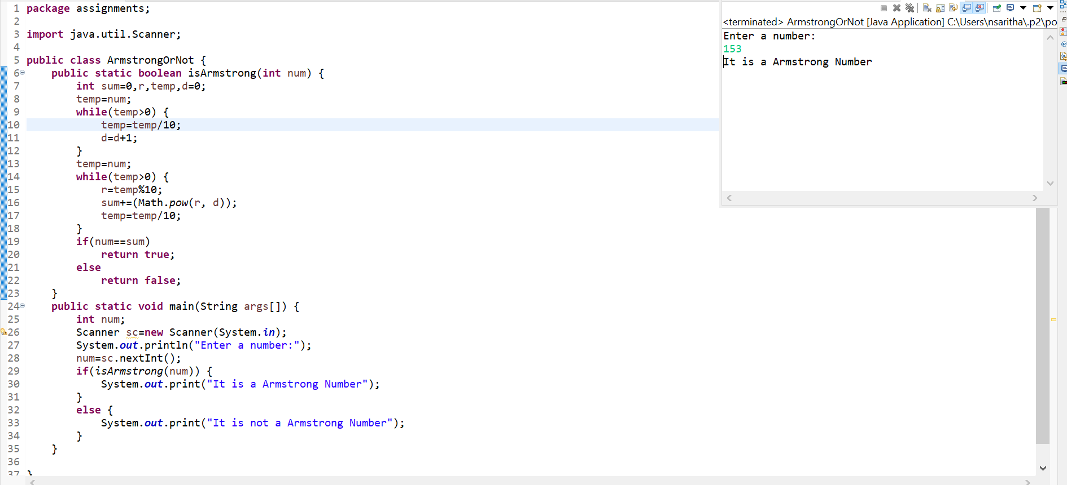

2.Find out all the Armstrong Numbers falling in the range of 100-999.

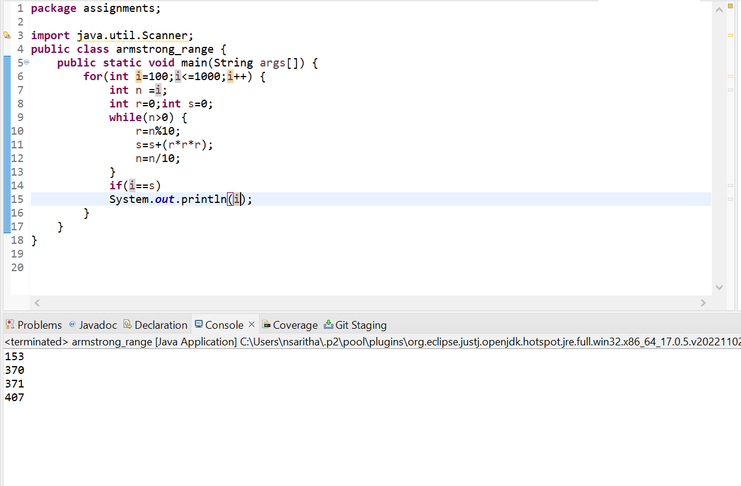

3.Find out the simple as well as the compound interest of supplied value.

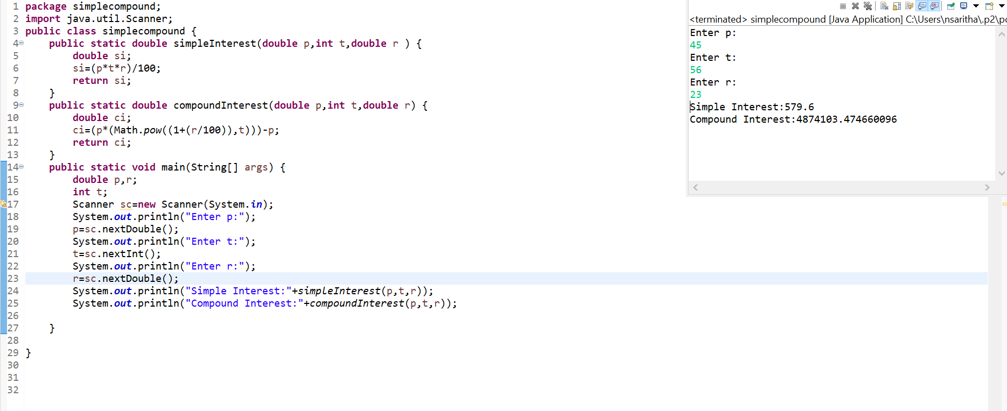

4.Supply marks of three subject and declare the result.

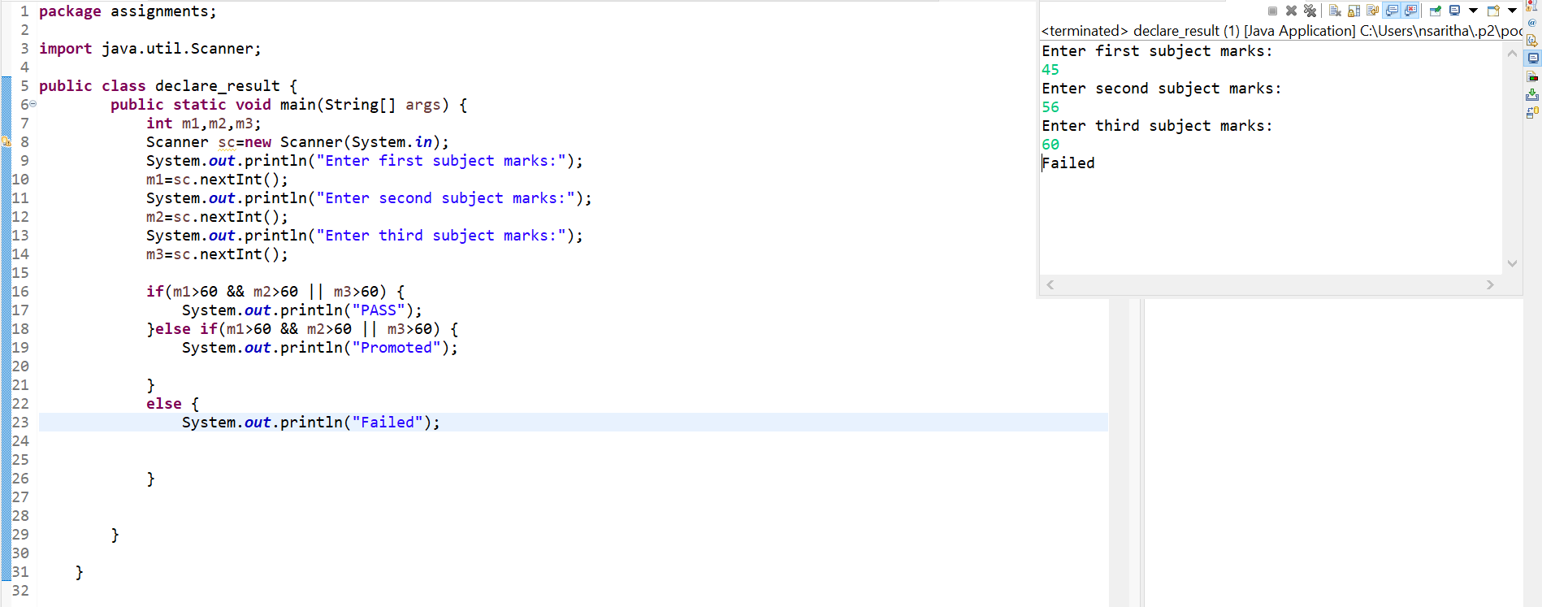

5.Calculate the income tax on the basis

Note:Assume slab is consider for Male,Female as well as Senior Citizen.

Accept CTC from users and display tax amount.

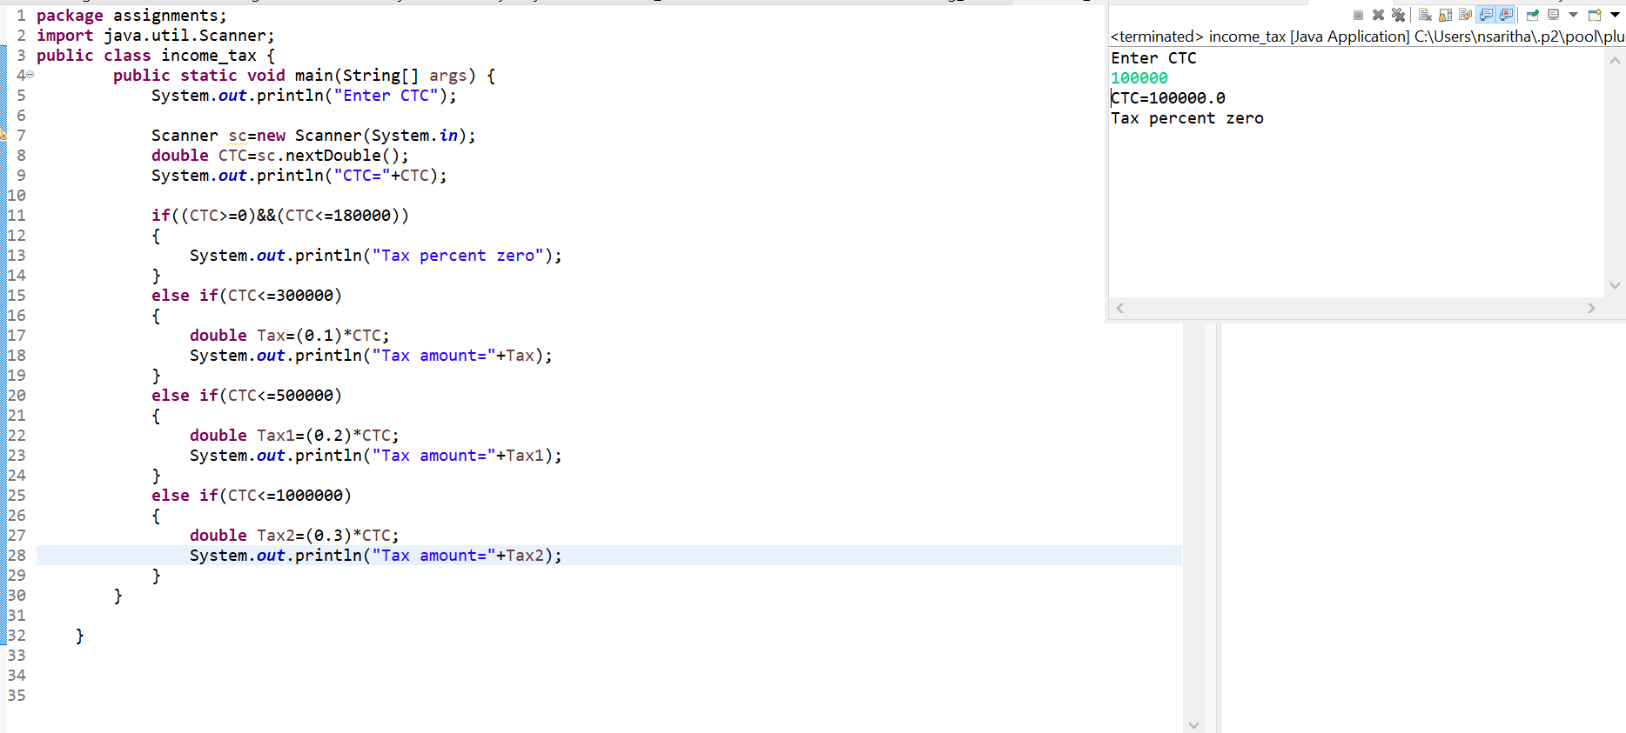

6.Consider a CUI based application, where you are asking a user to enter his login name and password, after entering the valid user-id and password it will print the “Welcome” along with user name. As per the validation is concerned, the program should keep a track of login attempts. After three attempts a message should be flashed saying “Contact Admin” and the program should terminate.

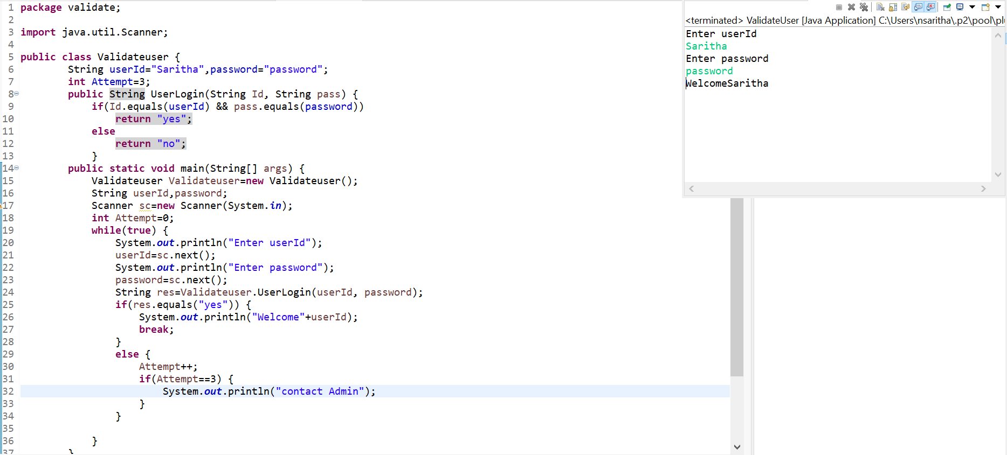

7.There is an Array which is of the size15, which may or may not be sorted. You should write a program to accept a number and search if it contained in the array.

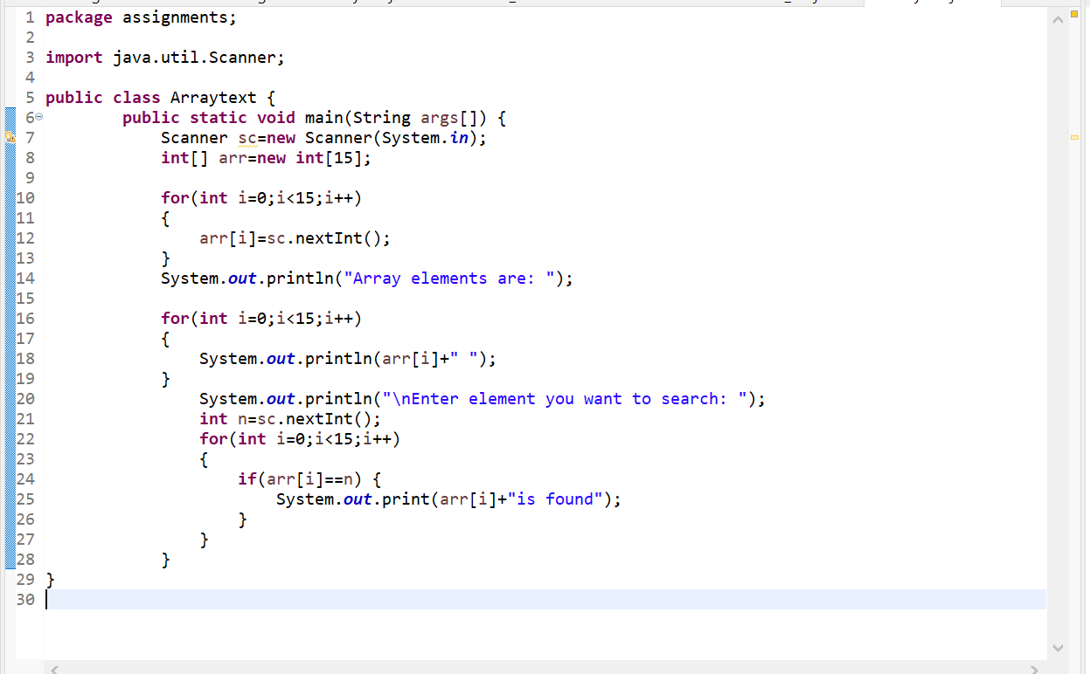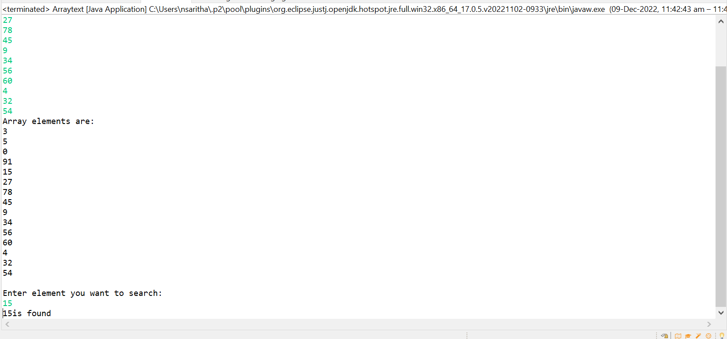

8.write method apply sorting using Bubble Sort.

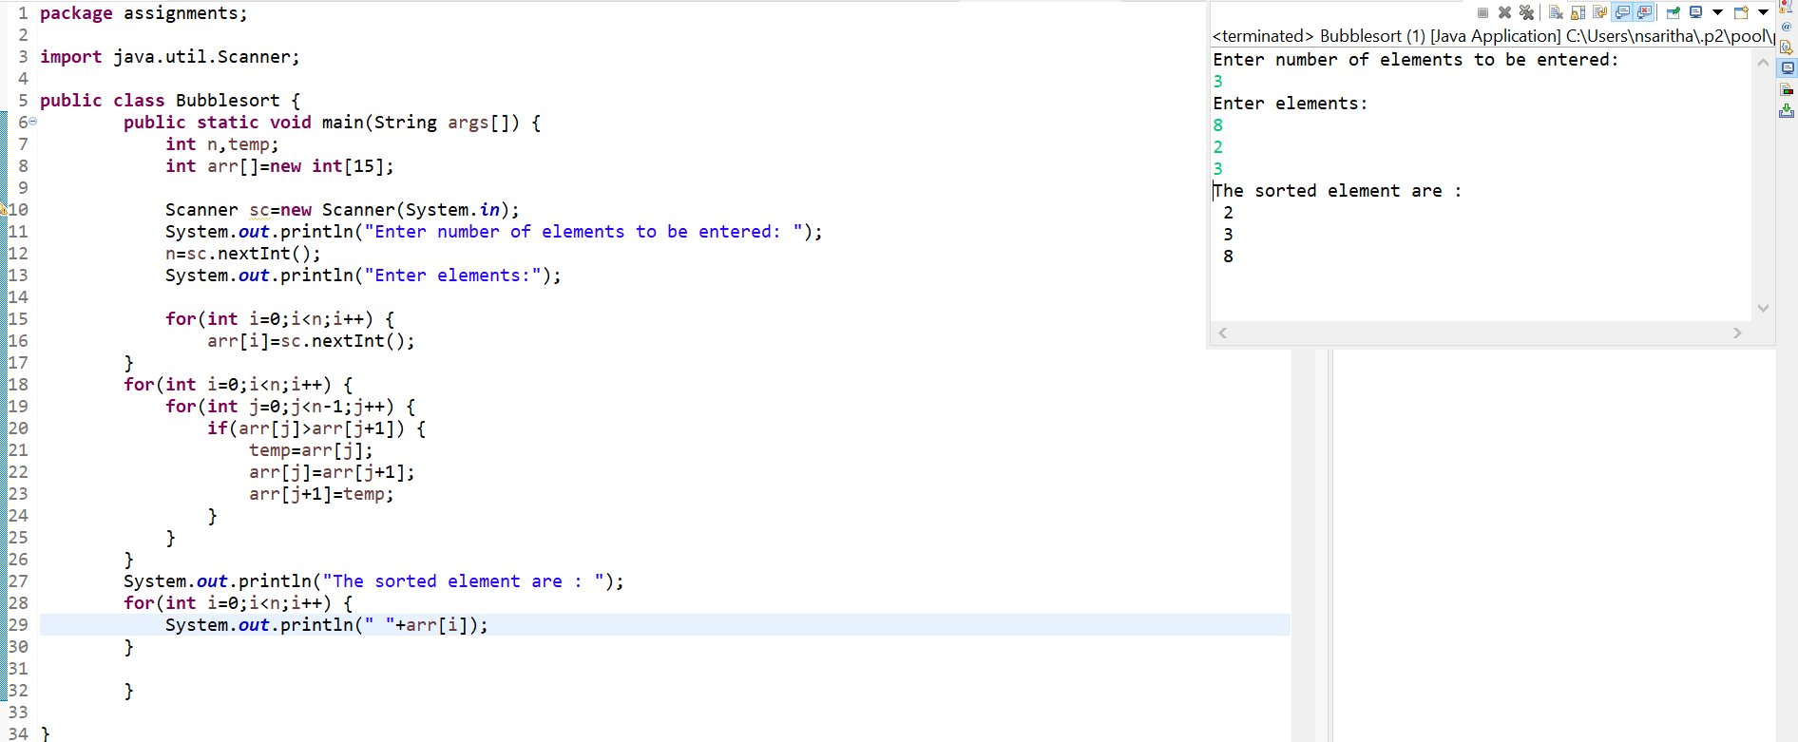

9.Accept the marks of three students for the subject say A,B,C. Find the total scored and the average in all the subjects. Also Find the Total and Average scored by students in each respective Subject.

